Allusion
Definition: A direct or indirect reference to something historical, literary, religious, or mythical. The author usually uses references that will be understood by his or her audience, such as an event, book, myth, place, or work of art. You can also make allusions to pop culture.
Why Writers Use It: Allusions can help people see unique connections between two ideas. The reference can help the audience better understand a subject. Allusions can also be surprising and funny, and are a favorite tool for rappers, writers (Family Guy) to prove their extensive knowledge of many topics.
In other words: dropping good allusions will make you sound smart.

“The side lines is lined with casualties
Who sip the life casually, then gradually become worse
Don’t bite the apple, Eve” -Jay-Z

“Family Guy” allusions

Hyperbole
Definition: A purposeful exaggeration or overstatement. In Greek, it literally means to overshoot.
Why Writers Use It: Even though the statement might not be exactly true, hyperbole can create emphasis or also make something sound funny.
“I’m so ahead of my time my parents haven’t met yet.” -Big L
“It’s a slow burg–I spent a couple of weeks there one day.” -Carl Sandburg

Extended Metaphor
Definition: A metaphor that continues over multiple sentences, and that is sometimes extended throughout an entire work.
Why Writers Use it: Extended metaphors allow writers to draw a larger comparison between two things or ideas. In rhetoric, they allow the audience to visualize a complex idea in a memorable way or tangible. They highlight a comparison in a more intense way than simple metaphors or similes.
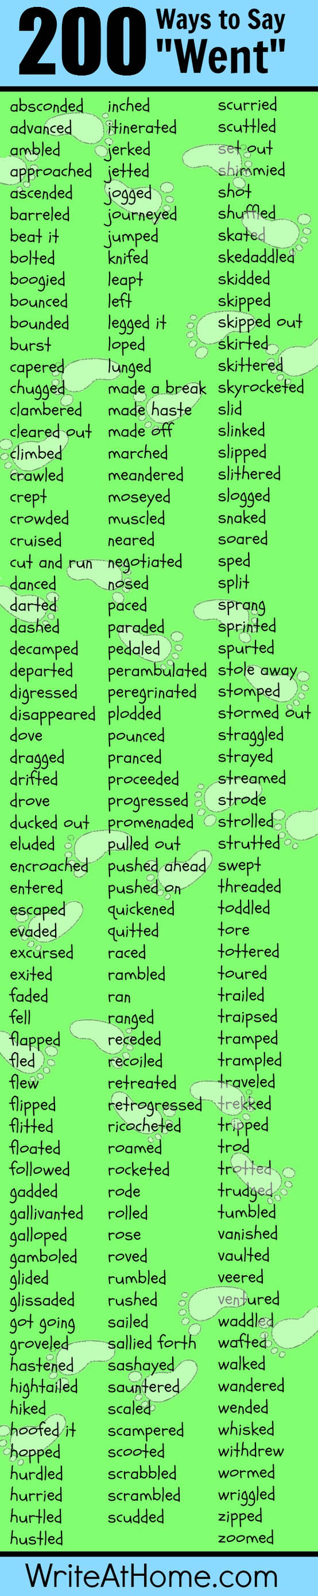
“The tumor is Al-Qaeda. We went in and wiped it out, but it had already sent out a splinter cell–a small team of low-level terrorists quietly living in some suburb of Buffalo, waiting to kill us all.”
-The TV show House
Using Specific Nouns

Dull nouns can be replaced with specific nouns to improve writing.

Example of dull nouns:
The man next door likes to eat beef for meals.

Example of specific nouns:
Mr. Johnson likes to eat sirloin steak for dinner.

Group==fix aloud:
- That little girl likes candy.

- Alphonso had meat, potatoes, vegetables, and a dessert for a meal yesterday

- Ralph put on warm clothing before he went out into the storm.

- After she won some money, she went downtown to buy some clothes.

Word Choice:
Six Principles of Word Choice
1. Choose understandable words.
2. Use specific, precise words.
3. Choose strong words.
4. Emphasize positive words.
5. Avoid overused words. (super, stuff, thing, good, bad)
“Friends’” Joey’s Adoption Letter

