Creative Write #1
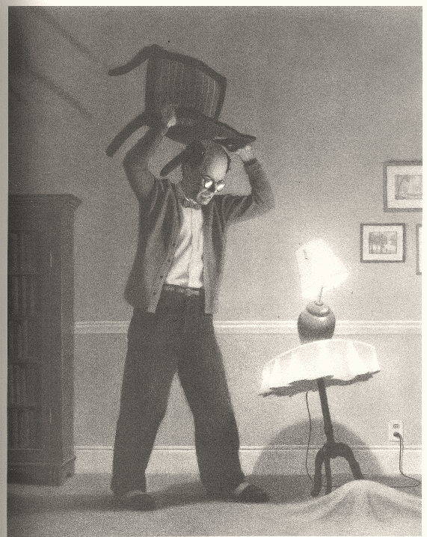
After seeing the picture and the caption, you are going to write a story that includes that line somewhere in your story. You will want to type your story to check word count. You will need to take this picture from my webpage and paste it onto your final submission.

Remember, this is a story that is about the picture. It can begin before this picture was taken, during, or after.
Requirements:

Heading (Name, Class, Hour, Date) Title
Caption from picture used
600 word max
Proofread and spell checked
Two weeks passed, and it happened again.

Creative Write #1
After seeing the picture and the caption, you are going to write a story that includes that line somewhere in your story. You will want to type your story to check word count. You will need to take this picture from my webpage and paste it onto your final submission.

Remember, this is a story that is about the picture. It can begin before this picture was taken, during, or after.

Requirements:

Heading (Name, Class, Hour, Date)
Title
Caption from picture used
600 word max
Proofread and spell checked
Two weeks passed, and it happened again.

