Book, Web, Journal APA Review Name: ____________________________

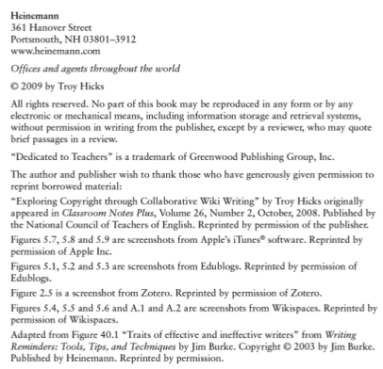
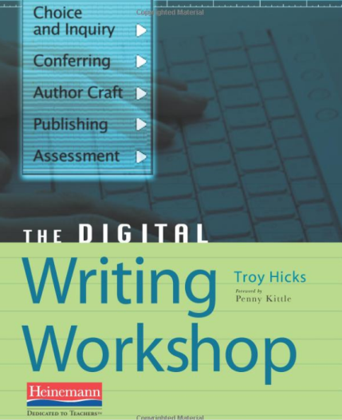
Books

APA Citation:

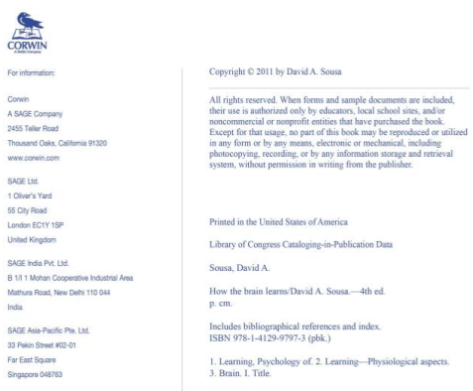
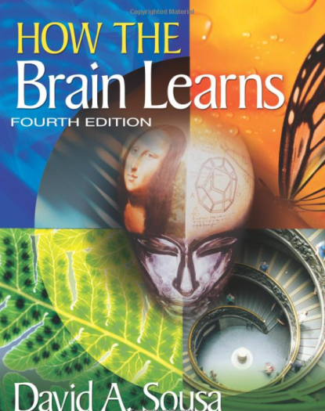

APA Citation:

Websites

- Properly cite the following link: https://www.edutopia.org/article/research-backed-approaches-bullying-todd-finley

APA Citation:

- Properly cite the following link: http://www.psu.edu/ur/about/nittanymascot.html

APA Citation:

Articles

- Literature Circles Go Digital by Bromley, Karen; Faughnan, Michelle; Ham, Susan; Miller, Melissa; Armstrong, Traci; Crandall, Cassandra; Garrison, Julia; Marrone, Nicholas.

APA Citation:

- Developing guidelines for return to play: Consensus and evidence-based approaches by Echemendia, Ruben J.; Giza, Christopher C.; Kutcher, Jeffrey S.

APA Citation:

