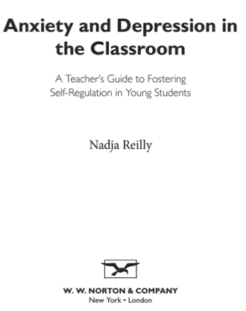
Book:

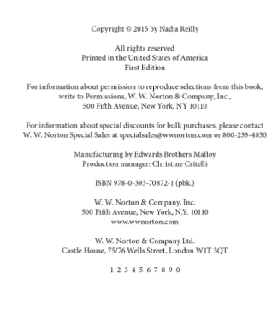
Cite:

Reilly, N. (2015). Anxiety and depression in the classroom: A teacher’s guide to fostering self-
regulation in young students. New York: W.W. Norton and Company.

Websites:

Properly cite the following link:
https://www.edutopia.org/blog/dyslexia-in-general-ed-classroom-kelli-sandman-hurley

Cite:
Sandman-Hurley, K. (2014, October 23). Dyslexia in the general education classroom. Retrieved
from https://www.edutopia.org/blog/dyslexia-in-general-ed-classroom-kelli-sandman-
hurley

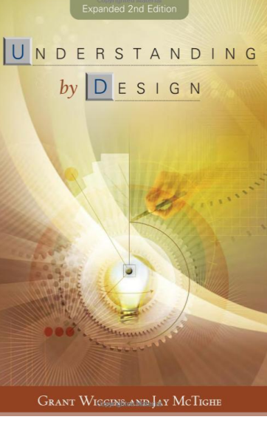
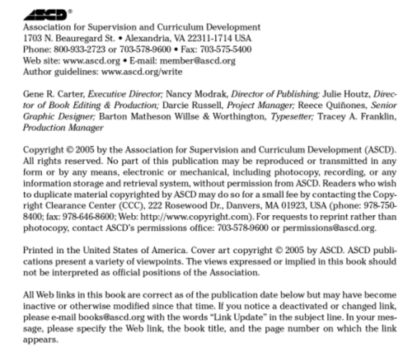
Book:

Cite:

Wiggins, G., & McTighe, J. (2005).
Understanding by design (2nd ed.).
Alexandria, VA: ASCD.

Websites:

Properly cite the following link:
http://blog.cengage.com/technology-classroom-distraction-asset/

Cite:
Strang, T. (2014, April 1). Technology in the classroom: A distraction or an asset? Retrieved
from http://blog.cengage.com/technology-classroom-distraction-asset/

