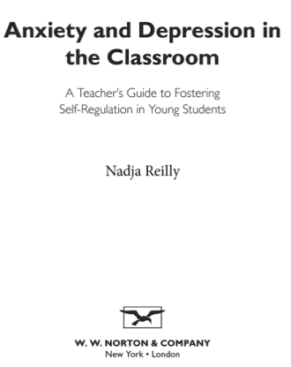
Book:

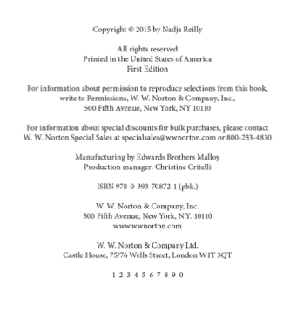
Cite:

Websites:

Properly cite the following link:
https://www.edutopia.org/blog/dyslexia-in-general-ed-classroom-kelli-sandman-hurley

Cite:

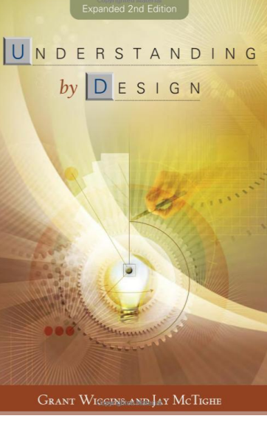
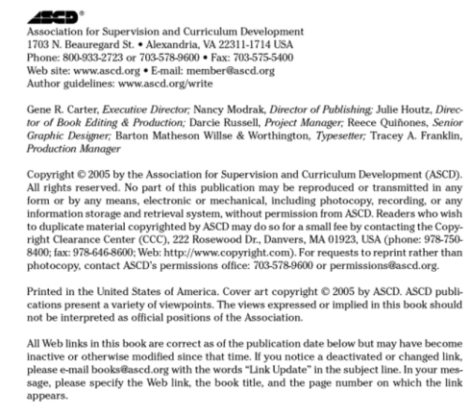
Book:

Cite:

Websites:

Properly cite the following link:
http://blog.cengage.com/technology-classroom-distraction-asset/

Cite:

